

Ibis

for Windows



Software for Printing Plastic Cards using

equipment

User’s Guide
Version 2.1.x

Table of Contents
Introduction 4
Installation 5
Initial Configuration 8
Communications 8
Configuration 10
Configuration -> Equipment 11
Configuration -> Preferences 16
Configuration -> Communications 18
Configuration -> Tools 20
Configuration -> Host Interface 22
Card Design 25
Description of the “GENERAL” Tab 27
Description of the “DATA FORMAT” Tab 30
POINT & SHOOT: 36
DATA FORMAT - 9000 Ready Type File 37
Defining 9000 Ready Type Files 38
Description of the “CARD FORMAT” Tab 41
Description of the Fields in the “SEARCH FIELD” Tab 47
Local Production 50
Batch Production 53
Fixed-Size Batch Production 56
Manual Data Entry 58
Remote Production 62
Host Requirements: 62
Reports 65
Report Content 66
Report Printing 66
Security / User Management 67
Users Management 68
Utilities 70
Reading Card Counters 70
Reading the Magnetic Stripe 71
Running the User File 71
HEX/Decimal/ASCII Table 72
Audit 73
Ibis Database Repair ToolKit 74
APPENDIX “A” 75
DataCard Connections Diagram 75
Fault Report 77
Index 78

Introduction

Ibis is an application software for PC’s under a Windows 95/98 environment to operate DataCard card personalization equipment.

Supported Equipment

Ibis can operate these machine models:

- DataCard 150i
- DataCard 280

Basic card personalization capabilities

The list below shows Ibis printing and personalization capabilities, depending on the features available in each equipment model:
- Mag Stripe Encoding (High and Low Coercitivity).
- Embossing
- OCR Indent.
- Flat printing (Grafix - DataCard 280).
- Topping.
- Chip encoding (Smart Card) - it requires additional software and a coupler to be installed on the hardware).
- Carrier printing – using a paper printer with its driver for Windows.

Functionality

Ibis can perform the following functions:
- Print cards in batches, individually or automatically.
- Design card format.
- Use different types of files. Design data record (record and field separators)
- Print audit reports.
- Set the equipment configuration, communication settings, etc.
- Define authorized users and assign privileges to each of them.

Security

- User’s password and privileges.
- Capability to set password renewal frequency.
- User’s suspension capability.
- Audit log of each task carried out by the user.

Installation

Installing Ibis on Windows 9x

- Close all applications running (Antivirus, Windows Explorer, Screen Saver, etc.)
- Insert CDROMM into the CD drive.
- From the Start - > Run menu, type d:\setup.
- Follow the instructions displayed on the screen by the installation program.
- We recommend installing Ibis in the directory by default: Ibis for Windows

Note:
During installation, the software may prompt you to cancel the installation, reboot your PC and then resume the installation.
This may happen if your PC has older versions of certain files than those being installed by Ibis.
It is common for this to happen. Therefore, when your are prompted to resume the installation, follow the steps below:

- Click OK and remove the disk from the disk drive.
- After rebooting your PC, insert disk No. 1 and run the installation program again until it has been successfully completed.
- Reboot your PC.

Installing Ibis on Windows NT

- Close all applications running (Antivirus, Windows Explorer, Screen Saver, etc.).
- Insert CDROMM into the CD drive.
- From the Start -> Run menu, type d:\setup.
- Follow the instructions displayed on the screen by the installation program.
- We recommend installing Ibis in the directory by default: Ibis for Windows

Note:
During installation, the software may prompt you to cancel the installation, reboot your PC and then resume the installation.
This may happen if your PC has older versions of certain files than those being installed by Ibis.
It is common for this to happen. Therefore, when your are prompted to resume the installation process, follow the steps below:

- Click OK and remove the disk from the disk drive.
- After rebooting your PC, insert disk No. 1 and run the installation program again until it has been successfully completed.

Important:
During the installation of Ibis, some drivers were copied into your PC for Ibis to recognize the Hard Lock key provided with the software (see “Running Ibis”).

Once Ibis has been successfully installed, follow the steps listed below:

- From the Start menu, click on Programs and then on Ibis for Windows
- Run “Install WinNT Drivers”.
- A screen opens. Click on the “Install Drivers” button.

Once the installation has been successfully completed, close the window and reboot your PC.

After rebooting your PC, you are ready to start producing!

Running Ibis

- Install the software hard lock key into one of your PC’s parallel ports (LPT1 through LPT3). We recommend first shutting down and disconnecting the equipment from your PC.
- If you have a printer, you should use a different port for Ibis hard lock key.
- From the Start menu, go to Programs and click on the Ibis icon.
- The first time you run the software, a window opens for the operator to select the language to be used (Spanish or English) and in the next window Ibis will automatically find the first communications port (COM 1 through COM4), displaying the port selected. If no port is found, an error message will be displayed indicating that there is no port available.

Note: if the port selected is not the one you wanted to use, you should change it manually through the Setup menu.

- In the Login window type the following (use these names until you have created your own users):
- User: user
- Password: user

Note: The password is case sensitive.

- Now you can use all the features offered by the software since the “user” user has all privileges assigned. If required, more users may be created and later on, you may delete the “user” user.

Important: do NOT delete the user “user” until you have created at least another user with the Supervisor privilege.

Note: Screen setup should at least be 800 x 600 pixels and 256 colors.

Ibis Main Window
User
LogOut
Local Production Local
Host Production
Card Design
Reports
Configuration
Audit Log
Hexa/Decimal/ASCII Table
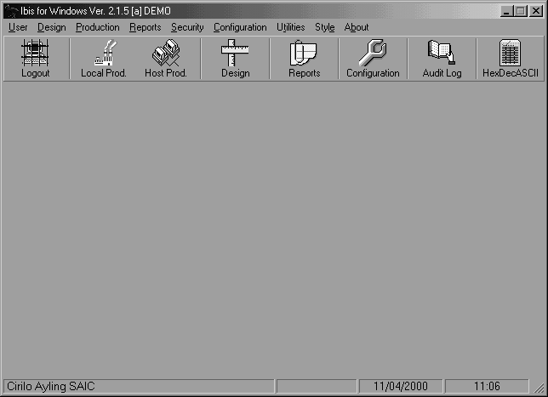

Initial Configuration

Follow these steps for software and hardware initial configuration:
- Turn off your PC and the DataCard equipment. Connect Ibis Hard Lock key and the serial cable from your PC to the DataCard equipment in the serial connector marked “Host” at the rear of the machine (See the sketch at the end of the manual). Turn everything back on.
- Click on the Configuration menu.
- Select the Equipment tab to set the equipment type and accessories.
- Select the Communications tab to define the communications settings:

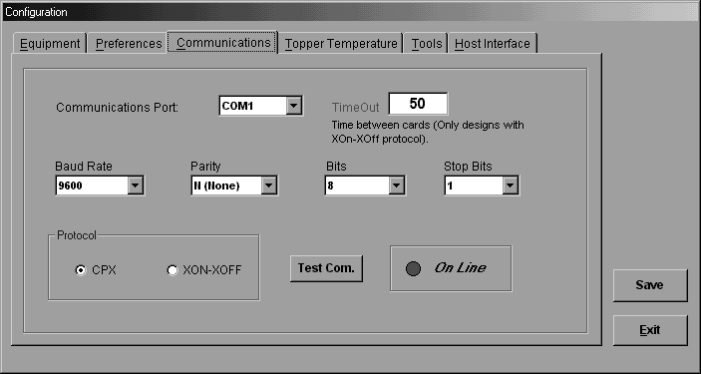
Communications

- Set the communications port (COM 1 or COM 2).
- Set the communications TimeOut at 50 seconds (as a minimum).
- Select the communications protocol:
- For DataCard 150i: CPX
- For DataCard 280: CPX or Xon/Xoff

Note: Xon/Xoff is faster while CPX provides more error control during card production.

- Define serial settings (Baud Rate, Parity, etc.). In order to do this, you should know the values used by the embosser. When using the CPX protocol, contact Cirilo Ayling SAIC for the required settings.

Note: For DataCard 150i try using Baud=9600, 8 Bits, Parity=No, 1 StopBit.
(Alternatively, try using 7 Bits and Even Parity or try Baud=19600).
For DataCard 280 or if using Xon/Xoff, enter the same values set in the machine.

- Check that the On Line indicator changes to green. If it stays red, check the cable, the serial port and the machine setup.
- After checking the On Line indicator, press the Test Com button. The machine will display the status of the internal counters. (If the protocol being used is CPX, the DataCard 280 only displays the value of a single counter, indicating the Grand Total of cards issued).
- If this is not displayed, check the cable, the protocol and the communications settings. Also check that the PC’s serial port is in operation.

“For further details on System Configuration, see the Configuration Section”.

Configuration

This section allows the operator to define various settings required to achieve a suitable communication with the equipment and Ibis correct operation.

To open the Configuration window, click on the “Configuration” menu, in the Main Menu. The windows shows a form with several tabs. Click on the tab you want to access. Each tab has configuration data sorted by subject.

After making changes, click on the Save button. You may leave the Configuration window at any time, by clicking on the Exit button but you will lose any changes made.

Note: To carry out this task, the user must have the Configuration privilege. Otherwise, the item will not be enabled in the menu.

Available Tabs:

Equipment: Sets special features of the personalization equipment.

Preferences: Sets working directories.

Communications: Sets the protocol type and the communications settings between the Ibis PC and the Embosser.

Tools: Allows you to set the additional tools (character replacement, carrier printing, etc.)

Host Interface: Allows you to set Ibis in automatic mode in a client /server environment.

Configuration -> Equipment
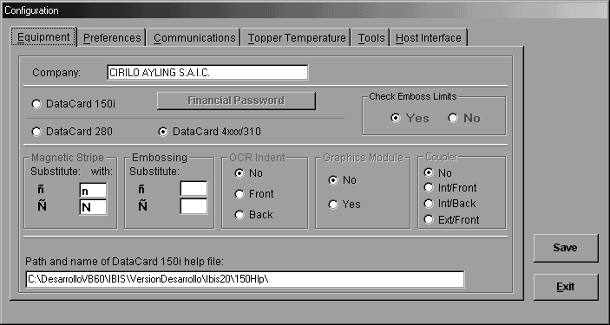
It allows you to set the following:

- The personalization equipment to be used:

Check the radio button next to the machine model to be used. The available models are:

- DataCard 150i
- DataCard 280

- The character to be replaced in the embossing:

If there is an ñ or Ñ in the text to be embossed. Next to the ñ or Ñ, type the character that will replace it.

Note: To emboss an Ñ, the data file must send exactly an Ñ. Ibis replaces the Ñ with the character typed in this window. The replacement is necessary when DataCard 280 is used. This model will normally be provided setup to emboss an “Ñ” whenever an “Exclamation Mark” (“!”) is sent (See also Configuration Menu / Tools / Replacement)

- The character to be replaced in the Mag Stripe:

If there is an “ñ” or “Ñ” in the data to be encoded in the mag stripe, next to the “ñ” or “Ñ” symbol, type the character that will replace it.

Important:
The following options must be properly set since they will be used later for badge production.

- OCR Options:

Check the radio button of the equipment actual setting. You may choose from:
- No OCR Indent
- Front
- Back

- Grafix Options:

Check the radio button of the equipment actual setting. You may choose from:
- No Grafix module
- Grafix module available

- SmartCard Options :

Check the radio button of the equipment actual setting. You may choose from:
- No SmartCard module
- Internal Front Module (card with front chip)
- Internal Back Module (card with back chip)
- External Front Module (card with front chip)

Financial Password - DataCard 150i:
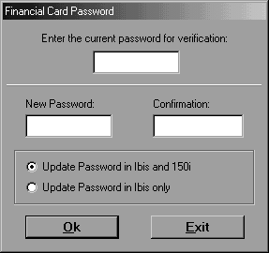
This option allows you to set the Financial Password required by the equipment to enable the option for printing cards with financial credit cards standard format. The machine recognizes this type of card through the format and the content of the data to be encoded in the Mag Stripe. The embosser recognizes the format of five types of credit cards and will only enable their production if Ibis sends the right password together with the data.
In other words, for Ibis to be used to issue cards with financial cards standard format, both passwords must match. Besides, the Host Authentication box in Card Design, General tab, must be checked.

- First Time Procedure

- Initially, the DataCard 150i has a password unknown by the distributor and the only way to initialize it is by using a tool (software) provided by DataCard to the distributor. Contact your DataCard Distributor to activate the password.
- This password is initially unknown simply for security reasons.
- The technician in charge of activating the password will use the Contingency 2 procedure to initialize the password to “DATACARD”.
- When installing Ibis, the initially recorded Financial Password is “DATACARD”.
- You may change the password using the General Procedure.

Summary: Only after your distributor’s technician has initialized the password in the equipment, can you change the Financial Password via Ibis.

- General Procedure

The Financial Password procedure automatically changes the Password stored in the 150i memory and at the same time the value stored in Ibis.

It’s a simple procedure but the following requirements must be met:

- The equipment must be connected to the PC where Ibis is running.
- The Financial Password must be previously initialized in the equipment.
- The current Financial Password in Ibis and in the 150i must match and must be known by the supervisor.

Note: The password is case sensitive.

After checking the items above, follow these steps:

- Connect the 150i to the PC where Ibis is running.
- Run Ibis and open the Configuration window via the menu or via the associated button in the toolbar located below the menu.
- Click on the Financial Password button.
- Check the “Update Password in 150i and Ibis” radio button.
- Enter the current password (check that the Caps Lock key is NOT activated).
- Enter the new password (check that the Caps Lock key is NOT activated).
- Enter the new password again for confirmation.
- Click on OK.

A message will appear indicating that the procedure has been successfully completed.

If the passwords in Ibis database and in the 150i do not match, the message will not appear.

Two contingency procedures are described below:

Contingency 1

If the passwords in the 150i and in Ibis do not match but you know both of them, use the following recovery procedure:

- Run Ibis and enter the Configuration model via the menu or via the associated button in the toolbar located below the menu.
- Click on the Financial Password button.
- Check the “Update only in Ibis” radio button.
- Enter the current Ibis Password.
- In the New Password field, enter the current 150i password.
- Enter the new password again to confirm.
- Click on the OK button. A message will appear indicating that the password has been changed.

Now the Ibis password and the 150i password should match. You can now use the General Procedure to change Ibis and the 150i passwords simultaneously, to any value you want.

Contingency 2

To be carried out by your Distributor’s Technician.

If you do not know the 150i Financial Password or it hasn’t been initialized, follow this procedure. You will need to use a software tool provided by DataCard.

- Connect the 150i to the PC notebook for DataCard Technical Support.
- Run the program included in the fx-2000 Kit Tech:
- Program name: PASSWORD.EXE
- Path: C:\DCC\COMM150i\PCAD
- Click on the “Set Financial Password to DATACARD” button.

The 150i Financial Password should now be DATACARD. Follow the contingency 1 procedure to set Ibis password to DATACARD, so that both passwords match.

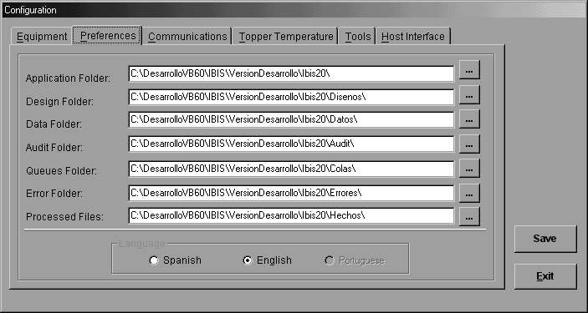
Configuration -> Preferences

It allows you to define different settings, as listed below:

Base Directory:

It allows you to set the folder where the application software is located.

Important: DO NOT change this directory, since it may affect Ibis suitable operation.

Design Directory:
It allows you to set the folder where the created designs will be located.

Data Directory:
It allows you to set the folder where data files can be found.

Audit Directory:
It allows you to set the folder where the audits of the cards produced in Manual Production mode (daily files *.aud) and the users’ actions (login, logout, etc.) will be recorded in the Auditlog.txt file.

Queue Directory:
It allows you to set the subdirectory where the data files received from the Host are recorded when operating in remote (Host) production mode.

Error Directory:
It allows you to set the subdirectory where incorrectly processed records will be stored enabling their subsequent reprocessing (This capability is not available in this version).

Language:

It allows you to choose the operation language. (Spanish / English).

Configuration -> Communications

It allows you to define the communications settings between your PC and the personalization equipment.

Communications Port:

Choose the Serial Port from the available options:
- COM1
- COM2
- COM3
- COM4

Serial Communications Settings:

Choose the communications settings (default values):

- Baud Rate = 9600
- Parity = O (odd)
- Bits = 8
- Stop Bits = 1
Note: These settings should match those defined in the personalization equipment.

Protocol:

Choose the communications protocol:

- DataCard 150i: CPX
- DataCard 280: CPX or Xon/Xoff

Note: Xon/Xoff is faster while CPX provides better error control during card production.

On Line indicator:

It shows whether the personalization equipment is properly connected, on and ready to receive data. The color code is as follows:

Green: Ready –Communication has been established

Red Not ready – Communication has not been established – Check communications settings

Test Com button:

Click on this button to try to communicate with the equipment. This test checks that Ibis communications settings match those set in the equipment.. If the communication is successful, the status of the equipment internal counters will be displayed on screen only if the protocol has been set to CPX.

Note: When using the DataCard 280, only the Total Number of Cards counter is displayed, showing the number of cards issued by the machine.

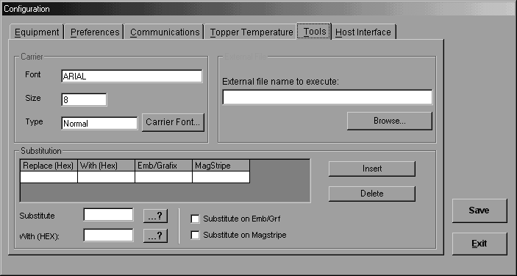
Configuration -> Tools

It allows you to set the following options:

Carrier

It allows you to choose the Font to be used to print the fields set in Card Design as Carrier Line Types (see Card Design Section) in a Carrier, using Windows default printer.

Character Replacement

It allows you to set a Character Replacement Table to be used by Ibis during production to replace the characters specified in the “Replace” field with the characters specified in the “With” field.

Replacement Example:
Suppose that in the data file to be processed, there are several “Ñ’s ” in the positions from which to extract the data to be encoded in the mag stripe track 1. In this case, you need the “N” character to be encoded instead of the “Ñ”. Therefore, you should replace all the “Ñ’s” with “N’s”.

There are two methods to do this replacement:

- Use a word processor or a database manager (depending on the type of data file to be processed) to physically change the characters altering the data file.
- Use Ibis Replacement Table to logically change the characters, without altering the data file.

To avoid editing the data file and making mistakes, use the Replacement Table.

Follow these steps to make the replacement for the example:

- Specify the characters values involved in the replacement

Replace (HEX) = Type the “Ñ” value in HEX
With (HEX) = Type the “N” value in HEX

Click on the ...? buttons to find the symbol to be replaced and the appropriate box will be filled automatically.

- Check the “Replace in Mag Stripe” checkbox.

- Click on the “Insert” button.

Now, during data processing, whenever Ibis finds an “Ñ”, it will replace it with an “N”, enabling Mag Stripe encoding.

If you want the change to be made in the embossing as well, check the “Replace in Emb/Grafix” box.

To delete any replacement, just select it and press “Delete”.

External File

It allows you to select the application that the User needs to run during card production by clicking on the “Search” button. This application is available in the “Utilities → Run User’s File” menu.

Configuration -> Host Interface
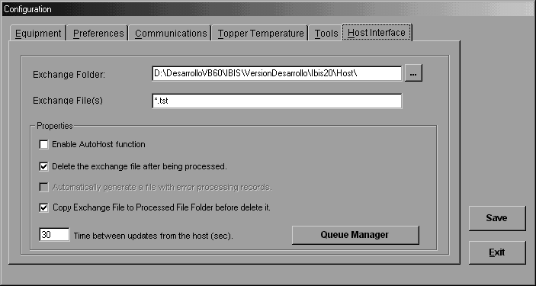

This option is used when Ibis has to work with a Host for production.

Remote or Host Production may be activated in TWO ways:

- Manually from the “Task → Production → Remote Control” menu.
- Automatically when starting Ibis.

Option b) implies that Ibis will automatically start and load the Remote Production module, waiting for the data file(s) sent by the Host. The Host will record a data file in a directory visible by Ibis. Configuration comprises the following settings:

Exchange Directory:
This is the path where the Host will copy the production files, i.e. where Ibis must search for the production files.

Exchange File:
It shows the file name and type to be searched by Ibis in order to start automatic production. It accepts wildcard characters. For example, *.TXT means Ibis will look for any file with a “TXT” extension.

- If you want you may check the box indicating Ibis to delete the file received If from the Host, once added.
- If you want, you may check the box indicating Ibis to create a list of the cards that have not been correctly processed, allowing for their subsequent reprocessing (unavailable capability).

Activate AutoHost Function:
By checking this box, you enable Ibis to automatically activate Remote or Host Production when it tarts running.

This is achieved by adding the following in Ibis command line:

- H → It indicates Ibis to start running in Remote or Host Production Mode. This function must be enabled in the “Configuration” module, “Host Interface” tab, “Activate AutoHost function” box.

Example:

Destination C:\Program Files\Ibis for Windows\IBIS.EXE H

There are two alternatives:

- Edit the icon properties:

If you have the Ibis icon on Windows desktop, right-click on the icon and then select Properties. A window will open, select the Direct Access tab (on top of the window) and type “H” at the end of the Destination field.

- Edit the icon properties in the Programs menu:

- If the Ibis icon is created upon software installation, right-click on the “Start” menu in the Windows toolbar and select “Open”. A window opens, double-click on the “Programs” icon to open another window where you will find the Ibis icon. Right-click on the icon and then select Properties to open the Properties window. Select the Direct Access tab (on top of the window) and type “H” at the end of the Destination field.

Search Frequency

It shows the time between searches made by Ibis to determine whether the Host has sent new files to the Exchange directory.

Queue Manager

A tool to control pending files.

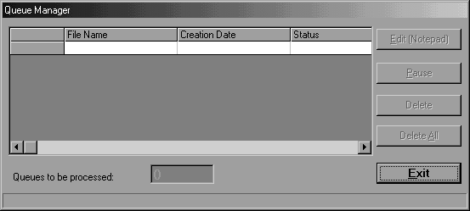

Card Design

Card Design is used to create or edit design files, which define all the card personalization features. The Card Design task allows you to have access to a wide range of possibilities to define, in a quick and easy way, from simple to complex cards.

Click on the Task → Design menu. The Design window will open.
Note: To activate this task, the user should have the Card Design privilege. Otherwise, the item will not be enabled in the menu.

The main screen displays a form with 3 tabs. Click on the tab you want to see. The available tabs are:

1) General

2) Data Format

3) Card Format

4) Search Field

At first, the General tab opens. All fields are disabled, except Design Name. The first step is to define the content of this field, according to the following instructions:

Choose an existing Design:
- Open the combo box below the Design Name field.
- A list with existing designs will open.
- Click on the design name you want to load.
- The program will load the design, filling the rest of the fields with the relevant data. These fields are enabled to allow for changes (if applicable), and access to the Data Format, Card Format and Search Field tabs is enabled.

Create a new Design:
- Type a new name in the Design Name field.
- Press Tab.
- If the name is new, a window prompting you to create a new design will appear.
Click Yes.
- The fields are initialized with default values and access to the Data Format, Card Format and Search Field tabs is enabled.
- Fill in the Description field with a brief description of the purpose of the new design.

Design Management:

- To save a new or changed design, click on the Save button.
- To save a design with another name, click on the Save As button.
- To delete a design, click on the Delete button.
- To exit the Design task, click on the Exit button.

Note: The Design task is independent from the hardware Configuration (as defined on the Configuration screens). This allows you to create designs for any machine type and configuration, without changing the Configuration. The operator, however, should pay special attention not to use resources that will be unavailable during production.

Description of the “GENERAL” Tab
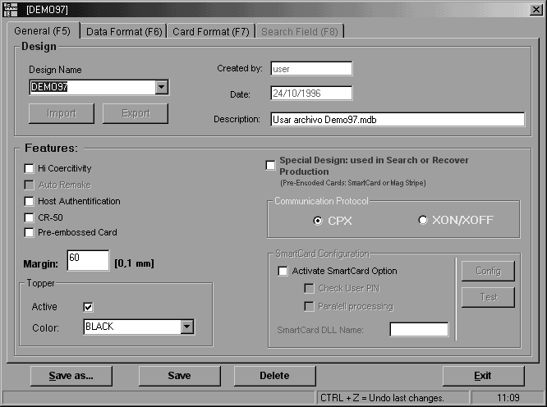

Created by
When creating a design, the system automatically fills in the name (alias) of the author user. This field cannot be changed.

Date
The date the design was created. This field cannot be changed.

Characteristics
- High coercitivity: It means that the Mag Stripe encoding will be made with high coercitivity.
Otherwise, the Mag Stripe encoding will be made with Low Coercitivity (default mode).
- Auto-Remake (unavailable capability)
- Host Authentication (See DataCard 150i Financial Password Section)
- CR 50 (small card)
- Personalized Card (only for DataCard 150i).

Offset
It shows the offset, in tenth of millimeter, from the left edge to the
position of the first embossed character.
This offset is common for all embossed and OCR lines.

Topper
It enables and disables the Topper. Once the Topper has been enabled, you may select the process temperature. The recommended value depends on the color of the Topper ribbon. Contact the ribbon supplier for assistance.

Design Used ...

To set the current design as a Recovery or Search Design. This means that when using this type of Designs, Ibis will require some information about the card in progress from the DataCard equipment and via the Search Field set. It will look for the associated record in the file chosen for production, thus completing card personalization.

Example:
A card is personalized with a user’s photo and his /her ID number encoded in the Mag Stripe. This card is then embossed by the DataCard 280.
Thus, there is no data error when transporting the cards from one machine to the other.

Communications Protocol

Each design created or edited with this Ibis version will manage its own communications protocol.
A different protocol is used because you cannot personalize a card electrically or use Recovery Designs with the Xon/Xoff protocol but with CPX.
Likewise, you should use CPX instead of Xon/Xoff to increase production speed.

SmartCard Configuration

Enable SmartCard Initialization:

- Validate PIN:

Check this box if the operator is required to enter his / her PIN to start card production.

- Parallel Processing:

Check this box if you want to increase Chip card production speed by up to 80%.

Description of the “DATA FORMAT” Tab
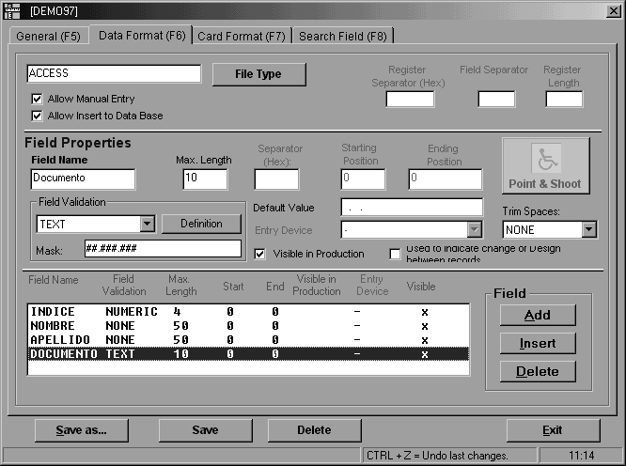

Use this tab to set how to read the data file with the personalization records to be used for card production.
On top of the form, choose the type of file from which personalization data is retrieved. Each file record has the data to personalize a card and in turn is divided in fields. The purpose of this form is to set how to read the file to separate its components.
- In the central part of the form, fields properties are shown.
- In the lower part of the form, there is a table listing all the fields set, indicating the most important properties.
- The central part of the form shows the properties of the field selected in the table.

First, set the file type to be used by clicking on the File Type button. There are six options. The form can be automatically filled with Access and Dbase only. Therefore, we have divided the explanation in three parts:

- Access Database File
- Dbase III – IV Files
- Other file types.

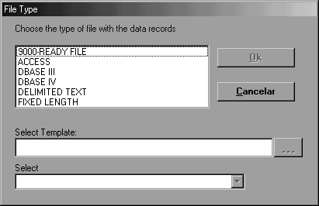

Some file types

Access Files:

- Choose ACCESS and click on Master File.
- Choose a database file that has the table with the personalization data (master table).
- Click on the arrow on the right of the Table field. A drop-down list opens showing one or more tables. Click on the master table.

Note: The table should have the same name and structure as the ones to be used for production.

- Click OK. The software will load all the information extracted from the table and fill in this tab of the form.
- If you want to use the “Manual Entry” production mode, check the Enable Manual Entry box.
- For Access files, there is a special option: to enable the update of the Database with the manually entered records in the “Manual Entry” mode.
- To activate this option, check the Enable Insert into Database box.

Note: This checkbox is available only if the option Enable Manual Entry has been enabled.

Dbase III – IV Files:

- Choose DBASE III or DBASE IV and click on the Master File button.
- Choose a *.dbf database file. Master File will then be filled with the Directory where your database is located.
- Click on the arrow on the right of the Table field. A drop-down list opens showing one or more tables. Click on the master table.

Note: The table should have the same name and structure as the ones to be used on production.

- Click OK. The software will load all the information extracted from the table and fill in this tab.
- If you want to use the “Manual Entry” production mode, check the Enable Manual Entry.
- For Access files, there is a special option: to enable the update of the Database with the manually entered records in the “Manual Entry” mode.
- To activate this option, check the Enable Insert into Database box.

Note: This box is available only if the option Enable Manual Entry has been enabled.

Other File Types

For other file types, the operator will fill in the fields manually.

TEXTO_LARGO_FIJO (FIXED_LENGTH_TEXT)

It is an ASCII text file where each record takes up the same number of bytes or characters. The software separates the records according to their length only. In turn, each record has fixed length fields.

TEXTO_DELIMITADO (DELIMITED_TEXT)

It is an ASCII file that uses a character to separate records and another character to separate data fields. It admits variable lengths.

ARCHIVO_9000 (9000_FILE)

It is a combination of TEXTO_LARGO_FIJO (FIXED_LENGTH_TEXT) and TEXTO_DELIMITADO (DELIMITED_TEXT). It is a Fixed-Length type file where each field has its own separator character and other special features.

“For further details, sea the DATA FORMAT - 9000 Ready Files section.”

After selecting one of the three types of files above, do the following:

- Enter the correct values for Field Separator, Record Separator or Record Length, depending on the file chosen.

Example:

Record Separator (Hex): 0D = Enter (commonly used)
Field Separator: Comma, Semicolon, etc.
Record Length: Line width plus 1.

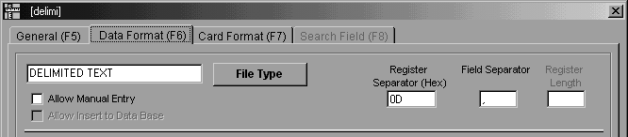

Note: The line width (record) may be obtained with the DOS Editor, by editing the file and pressing the “End” key, and then taking the value displayed in the bottom right corner.

- If you want to use the “Manual Entry” production mode, check the Enable Manual Entry box.
- The operator will then have to add the fields and, in each case, complete the boxes that show their Properties, in the central part of the form. The bottom part of the form summarizes the Fields and Properties loaded.

Depending on the file type, complete the following fields:

TEXTO_LARGO_FIJO (FIXED_LENGTH_TEXT): Record Length
TEXTO_DELIMITADO (DELIMITED_TEXT): Field Separator and Record Separator

Record Length
It determines the number of bytes that make up a record.
It implies that the data file must have a constant number of
bytes for each record.

Field Separator

It determines the character that separates each field.
The Field Separator field can be completed with a special character
(brackets, special signs, etc.), which are normally used
as separators.

Record Separator

It determines the character that separates each record.
The character’s hexadecimal value must be entered.
To determine the character’s hex value, you can use the Hex/Decimal/ASCII Table from the Utilities menu.

Add a Field

- Click on the Add Field button (located on the bottom right side of the form). A new line will appear in the main display, called “NEW” and with “default” attributes. The Properties in the middle of the form will be filled with those values.
- Click on the windows of each Property and enter the desired values.
- After editing all fields, press Save As or Save.
- The system allows you to delete a field by pressing Delete Field.
- You can also insert a new field before the first one or between any pair of fields previously entered by pressing Insert Field. The order of the fields must be maintained in the case of TEXTO_LARGO_FIJO type files.
- The system accepts up to 100 fields.

Properties of Each Field

Name
Field name. In the case of ACCESS or Dbase type files, this name is taken directly from the database table.

Start and End Positions
This property is used only for TEXTO_LARGO_FIJO type files. It determines the start and end positions of the field within the record.

Data Validation
It defines the validation in the field.
- None (alphanumeric)
- Text (letters)
- Numeric
- Date.

Length
This data defines the maximum number of characters allowed and is used only in Production when data is entered manually from the keyboard (Manual Entry option).

Default Value
A default value may be entered. This data is used to initialize the field when the data form is displayed in the Manual Entry mode.

Value Displayed during Production
This box indicates whether the data will be displayed during Production, in the Information Panel. If you do not want the data to be displayed, just click to remove the cross (or check mark) from the box.

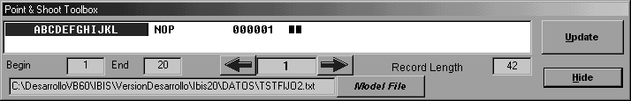
POINT & SHOOT:

Choose File Previous Record Next Record Update Values in Data Field Definition

Hides Point&Shoot

This tool allows you, via a master file, to set the Record Length, the fields and their values, such as start and end.

- Click on the Point & Shoot button
- Click on the Master File button
- If you have not set the Record Length yet or if you must correct it, first you should hide Point&Shoot, set the Record Length and then load this tool again.
- Ibis will automatically display the first record.
If the Record Length is correct, two little black boxes will appear at the end of the record. Otherwise, you should correct this value, repeating steps 3 and 4.
- Now, add a NEW field in the previous window by pressing “Add Field”.
- Go back to Point&Shoot and select the text part that belongs to this field by clicking on the desired start position without releasing the mouse left button and drag until the desired end position. The values of the “Start” and “End” fields will change.
- Once you have set the values, press “Update” to update the values of the Design window.
- Repeat this procedure for each field that you want to add. (Steps 4 through 7)
- Once you have set all the fields, press “Hide” to go back to the previous window.
- Check all data for correctness.
- Finally, save the changes made by pressing “Save”.

DATA FORMAT - 9000 Ready Type File
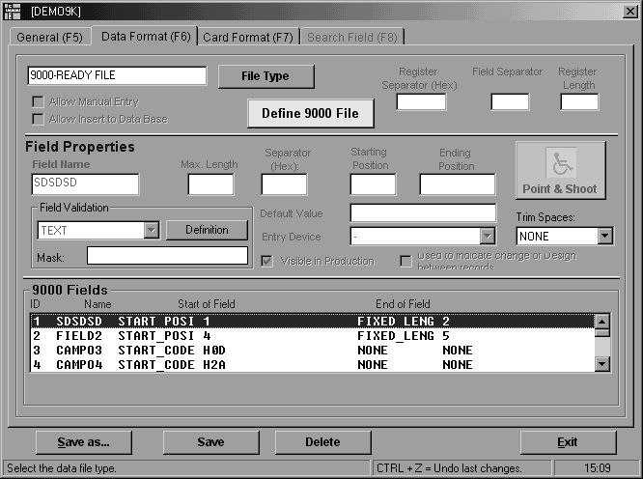

9000 Ready Type data files are TEXT files, but with certain features that make them a little more complex.

Like text files, these are made up of Records which in turn are made up of Fields.
Below you will find a description of how to define this type of files.

Defining 9000 Ready Type Files

Once the Type of File has been selected as 9000 Ready, a button called Define 9000 File appears in the center of the screen and the rest of the common controls pertaining to the other Types of Files will be disabled .
Press this button to open a window where you can define all the necessary features for Ibis to correctly identify and process a 9000 Ready Type file.

Records of a 9000 Ready Type File

The Records can be defined as Fixed Length Records or Variable Length Records and this feature determines how Ibis must locate the end of the record.

Unlike normal Text files, in the 9000 Ready Files, lines do NOT necessarily represent records, because records can be concatenated one after the other, no matter whether it is a FIXED LENGTH or a VARIABLE LENGTH file .

- FIXED LENGTH Records
When defining a 9000 Ready file as FIXED LENGTH, you should specify the length of the Record (measured in bytes or characters) which determines the number of characters to be read and processed.

- VARIABLE LENGTH Records
When defining a 9000 Ready file as VARIABLE LENGTH, you should specify the Record End Codes.
The Record End Codes are a series of Hexadecimal Codes which can be made up from 1 to 7 consecutive codes. These codes are special characters in the ASCII Table (printable or not), which will be used to identify the Record End.

Fields of a 9000 Ready Type File
The fields of a 9000 Ready File can be defined by the Start Methods and the End Methods.

Start Methods
These are the different ways to identify the start of a field:

- None
Specifying None, the field begins directly where the preceding one ends.

- Start Code
Specifying Start Code, the field begins where said code is found. From 1 to 7 characters. To achieve a better performance, we recommend using only one character.
- Start Position
Specifying the Start Position, the field begins in the specified position.
This procedure is much more effective than the others but it REQUIRES preceding fields to be of the FIXED LENGTH type.

End Methods

These are the different ways to identify the end of a field:

- None
Specifying None, the field ends when the beginning of the next field is identified.
It REQUIRES the next Start Method to be Start Code or Start Position.

- End Code
Specifying End Code, the field ends where said code is found. From 1 to 7 characters. We recommend using only one character to achieve a better performance.

- Fixed Length
Specifying Fixed Length, the field ends after the specified number of character.

- Embedded Length
Specifying Embedded Length, the number of data characters is specified in the same field.
This type of fields is required for those fields that have binary data (data for Ultragrafix, Color Photos, etc.).

- Ultragrafix Data
Used only for those fields with data for Ultragrafix without binary data embedded. With this type of End Method, there is neither Embedded Length nor Ending Code because the program will look for the Double Delimiter specified in the Ultragrafix field itself.

9000 Ready Type Files Definition Window
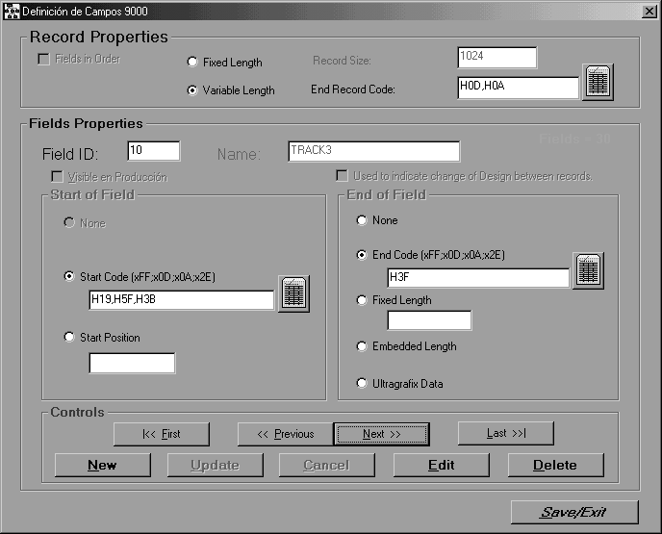
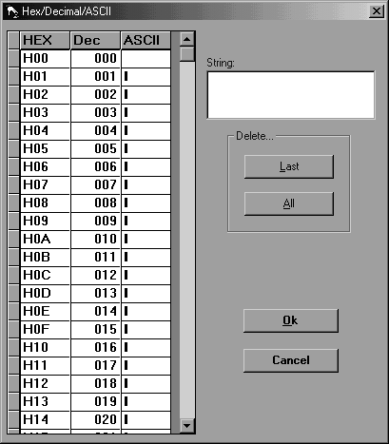
With this tool the Start or End Codes of each Field or Record are specified.

Description of the “CARD FORMAT” Tab
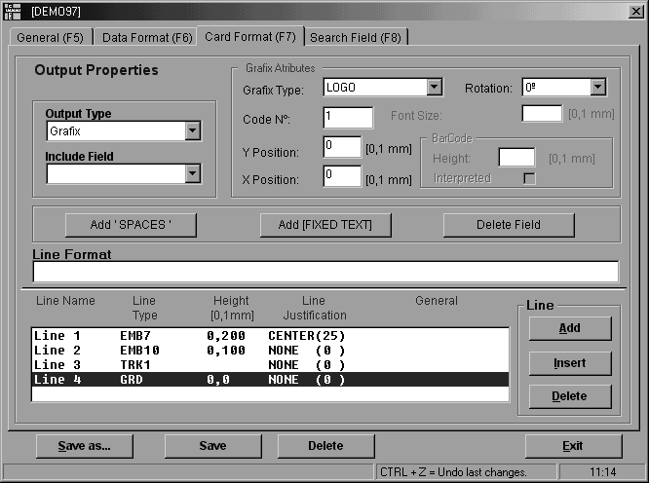

This tab of the form allows you to define all the outputs that determine the look of the card, and if required, the printing of the Carrier in a paper printer connected to the PC.
Line is defined as an output that is sent to the embossing machine (or to the Carrier Printer). The type of Line defines the end device, for example:
- A text line to be embossed
- A text line to be printed with Grafix (DataCard 280 with Grafix)
- A Mag Stripe encoding command
- A line to be printed on the Carrier.
This form is somehow similar to the Data Format one, in that in the bottom there is a frame that shows a summary of the existing Lines. These can be added, inserted or deleted using the buttons on the right of the table. The upper central part of the form shows the properties corresponding to the line selected on the frame. To select a line, click on the frame, anywhere on the line.

Adding a Line

- Push the Add Line button and a new line will appear in the table, numbered in ascending order.
- The sorting of the lines is irrelevant. Thus, the use of the Insert Line button (which allows you to insert lines into the existing ones) is less critical than the Insert Field one. However, this button is useful to keep a better sorting, since it helps to create lines sorted by type.
- The maximum number of lines is 30.
- Once the line is created, select it and adjust its properties.

Types of Lines

Type of Lines: choose the type of output from the following available options:

- Emboss 10 cpi (embossing of 10 charact./ inch - FC1 in the config. of the embossing machine)
- Emboss 7 cpi (embossing of 7 charact./ inch - FC2 in the config. of the embossing machine)
- OCR 10 cpi (OCR Indent - FC3 in the Configuration of the embossing machine)
- OCR 14 cpi (OCR Indent - FC4 in the Configuration the embossing machine)
- OCR 7 cpi (OCR Indent - FC5 in the Configuration in the embossing machine)
- Track 1, Track 2 and Track 3: Encoding the Mag Stripe tracks. The program automatically adds the starting and ending characters (sentinels).
- Preformatted Track: Allows mag stripe encoding. In this case the program assumes that the data field obtained from the record already has the special start and end codes of each track. Therefore, it does not add the sentinels and instead uses them to address each track. Since tracks 2 and 3 use the same sentinels, the order of the tracks must be observed, and in case you want to record track 3 but not track 2 the field must include the sentinels without data for track 2.
- Grafix: Printing of a text line in a Grafix system.
- Carrier: Printing of a text line in an auxiliary paper printer connected to a PC and integrated to Windows with the respective. It must be installed as the default printer.

Line Format

This property determines the data included in the line. Devices to assist the operator in the editing of this important property have been provided. The Line Format can add Fixed Texts and Variable Fields components to achieve a complex line, such as it should be printed on the card or encoded in the magnetic stripe. Below you will find an explanation of how the editing should be made:

Variable Fields

Normally a line uses information coming from one or more Variable Fields. A Variable Field is a data field extracted from the personalization data file. The system allows you to reference the fields previously defined in the Data Format tab. This is why you must complete this form before filling in the Card Format one.
When you use a Variable Field, it means that during production, the data of this field, taken from the record of each card, will appear in this place.

Include Field

It allows the automatic inclusion of a Variable Field in the Line Format. Pulling down the Include Field combo box you will see the list of fields. [If there are not any fields defined in the Data Format, the list will be empty.] When choosing one of the fields (by clicking on it), you will see it is included in the Line Format window.

Concatenated

If you include another field in the same line, you will see that its name is added to the Line Format window, separated from the preceding field by a plus [+] sign. Each component of the Line Format must be joined to the preceding one by this sign and this means that the components are being concatenated.

Fixed Text

Words or characters can be included, which will appear identically in the output. This is achieved simply by editing the Line Format check box to add the desired fixed text.

Rules for the addition of Fixed Texts:

The fixed text must be written between brackets. Example:[ABC].
The preceding and the following components must be concatenated with the plus (+) sign.
The use of symbols that are not allowed for the type of output in question should be avoided (for example, do not use letters where only numbers are allowed).

Examples:
- One Fixed Text only:
[SOCIO ASEGURADO] = SOCIO ASEGURADO
[INSURED MEMBER] = INSURED MEMBER
- Two concatenated Fixed Texts:
[ASEGU] + [RADO] = ASEGURADO
[IN] + [SURED] = INSURED
- One Fixed Text and one Variable Field:
[0449/] + NUMSOCIO = 0449/00023
[0449/] + NUMMEMBER = 0449/00023
- Two Variable Fields and one Fixed:
MES + [/] + AÑO = 03/97
MONTH + [/] + YEAR =03/97

An easy way to add Fixed Text is by clicking with the mouse on the desired position of the Line Format checkbox and then pressing the Add [Fixed Text] button. Then, you can type the desired text.

Spaces

A special fixed text format has been created for Space characters since these are widely used and when you have to enter many spaces, sometimes it may be hard to count them on the screen. You can concatenate one or more blanks simply by expressing the desired number of blanks between simple commas. The number indicates the desired number of blanks. Example: ‘5’ indicates you wish to include 5 spaces.
Besides, you need to use this mechanism when you wish to enter fixed texts with one or more spaces at the beginning and/or at the end of the fixed text. This is because the program eliminates the spaces that appear at the beginning and at the end of fixed texts and variable fields. Space components must also be concatenated to the rest of the components.

Examples:
- [SOCIO ] + NUM = SOCIO12345
[MEMBER ] + NUM = MEMBER12345
- [SOCIO] + ’1’ + NUM = SOCIO 12345
[MEMBER] + ’1’ + NUM = MEMBER 12345
- [PERSONAL] + ’8’ + [GUARDIA] = PERSONAL GUARDIA
[PERSONAL] + ’8’ + [GUARD] = PERSONAL GUARD
An easy way to add Fixed Text is by clicking with the mouse in the desired position of the Line Format checkbox and then pressing the Add [Fixed Text] button. Then you can type the desired text.

Combined Example

Suppose you wish to make up an embossing output that contains the valid from and thru dates of a card:
******VALIDO*DESDE*mm/aa*HASTA*mm/aa
******VALID *FROM*mm/yy*TO*mm/yy
- Each asterisk (*) represents a space.
- “VALIDO DESDE” y “HASTA”
“VALID FROM” and ’TO” are two fixed texts
- mm/aa (mm/yy) represents the date in month/year format. The value of the dates is extracted from two variable fields that are called FECHA_ALTA and VENCE (DATE_ADD and DUE_DATE)The slashes [/] are included in the data file.

The Line Format should indicate:

‘6’+[VALIDO DESDE]+’1’+FECHA_ALTA +’1’+[HASTA]+’1’+VENCE
‘6’+[VALID FROM]+’1’+ADD_DATE +’1’+[TO]+’1’+DUE DATE

The printed result will be: “ VALID FROM 07/96 THRU 07/97”

Attributes of Each Type of Field

When selecting or inserting a line, a frame appears in the top right hand corner of the form where you can define additional properties depending on the type of line:

- Embossing and OCR

Position X (Height)

- Magnetic Stripe

Prerecorded data (see below)

- Grafix

X and Y Positions, Type of Graphic (Font, Bar Code or Logo), Font size (Only for Font type).
For Bar Code you must define Width, and whether or not it is Interpreted.

The interpretation of the Code depends on the Type of Graphic chosen:

- Font: Represents the font style to be used.
- Logo: Represents the logo number loaded into the
DataCard 280.

See the Administrator’s Guide on how to load logos into the DataCard 280 memory.

- Bar Code: Represents the Bar Code style.
(For further details refer to the DataCard 280 manual).

- Carrier
X and Y Positions.

Note:
In this version, the value of X Position is not applicable for Embossing and OCR. The original position is defined in all cases by the Offset value (See General Page). If you need to move a line to the right, you will have to add blanks to the left of the text.

Pre recorded Data (DataCard 150i)

This feature allows the 150i to positively identify a credit card by the data recorded on one of the magnetic tracks..

This feature is only available for Track 1, 2 and 3 type lines. The system admits only one line with Prerecorded Data. You will hear a beep tone if you attempt to activate another line.
To activate the Prerecorded Data feature follow these steps:

- Select (or create) the line for Track 1, 2 or 3 where the prerecorded data should be. (Blank Cards should come previously recorded in that track).
- Click to activate the Prerecorded Data check box.
- Enter the number to be found in the cards in the text box.

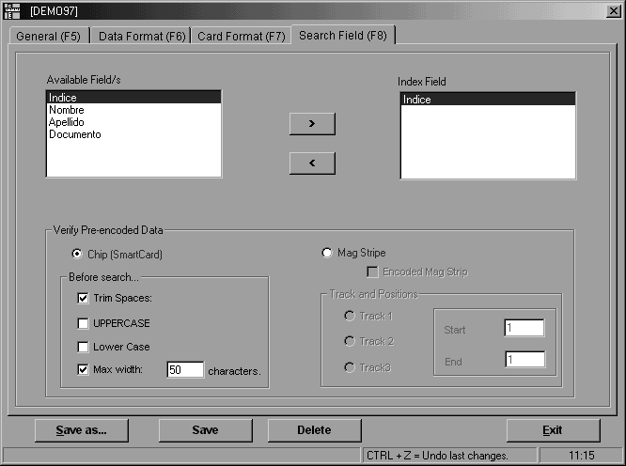
Description of the Fields in the “SEARCH FIELD” Tab
1 2

Ibis can personalize a card starting from special data encoded on the Magnetic Stripe or on the Chip.
This tool becomes useful when you need to personalize a card with a color photo and/or a color logo and embossed data (topping). The DataCard 150i and 280 only personalize embossed data; therefore, the photograph and/or the logo are made with another DataCard machine for flat personalization.

This tab of the form allows you to define the Search Field through which Ibis will identify each card and will then search its data in the file to be processed, thus completing card personalization.

There are two long lists in the upper part of the tab. The first list shows the Available Fields, previously defined in the DATA FORMAT page, to be used as Search Fields, and the second list shows the Field set as Search Field (You can define only ONE Search Field).

Properties of the Search Field

- The Search Field can be any field that during production will end either on the Magnetic Stripe or the card Chip.
- The data type of the Search Field can be of any kind.

Suggestion:
To achieve a better performance in data comparison, the Search Field should be the one that has a unique numeric data, since if there is more than one record with the same data in the Search Field, Ibis will use the first one found.

How to choose the Search Field

There are two ways to select the search field:
1 – Double click on the desired field
2 – Click on the desired field and then use the buttons located between the lists.

Definition of the Type of Search

We must differentiate the search between:

- Search through SmartCard (Chip Card) – Table No. 1
To perform the search through data from the card Chip, Ibis will request that data from a DLL created by the customer according to the specifications of Cirilo Ayling SAIC – Development Department.

Delete spaces

Deletes the blank spaces at both sides.

All to UPPER CASE

Converts the data received to Capitals.

All to lower case

Converts the data received to small letters.

Maximum Width

Compares only the specified width of the data received.

- Search through Magnetic Stripe - Table No. 2
To perform the search through data recorded on the Magnetic Stripe, Ibis will have to read the whole Magnetic Stripe and select that data from the values set for that Search Field.

Re-record Data
Indicates Ibis to re record the Magnetic Stripe if required by any Production line. Otherwise, it skips it.

Track and Positions
You should specify the track where the key data is encoded and the positions between which the portion of data to be compared is located.

Local Production
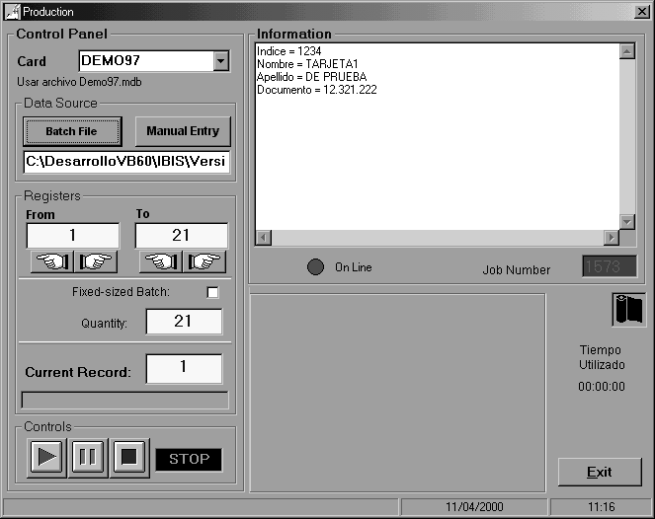

The Production task is used for card personalization.
Note:
To enable this task, the user should have the Production privilege. Otherwise, the menu item will be disabled.

Click on the Task→Production menu. There are two options:

- Local Production: To issue cards (in batch or individually) with the data entered in your PC.

- Remote Production: to issue cards controlled by a remote Host. Ibis awaits the data from the remote Host (See the Remote Production and Configuration Sections).

Click on the Local Control item to open the Production window.

Several items will be displayed in this window. At first, all the fields will be empty. The main groups are described below:

- Control Panel (left side)
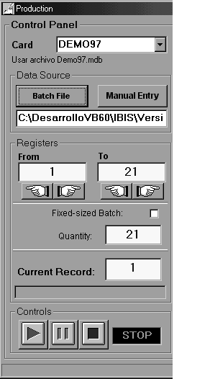

Card Design
Through these fields, the operator sets the “design” of the card to be produced. The design shows the personalization processes, defining the specific settings of each type of card defined. These settings are defined in the Design task (Section 4).

Data
It allows you to choose the source of the personalization data for production:

- Data entered manually by the user before issuing each card.

- Data from a disk file for batch processes.

Record Fields

Each record represents a card to be produced.

Controls

Controls
These buttons are disabled until the Card Design is set and a Data File loaded.
On the right, there is a status display showing the machine’s current status. Initially, the status is STOP, indicating that the machine is idle.

- Information Panel (top right corner)

It shows the value of each field belonging to the current record.

Below is the On Line indicator showing the machine status, as per the following color codes:

Green: Ready (On Line) – Flashing, equipment in operation.

Red: Not ready.

If the light is red, check that the equipment is on and properly connected to the PC.

The Job Number indicator is on the right.

- Diagram (bottom right corner)

It shows the activity in progress.
During personalization, this diagram displays the production status, the process underway and certain failures in a red icon.



Ibis is personalizing a Chip Card.



Ibis detected a personalization problem.

Batch Production

You can personalize cards using the data obtained from a disk file. Follow the instructions below.

Note: If you want to issue cards entering the data directly from the keyboard of your PC, refer to Manual Entry.

- Choose a Card Design.
- Choose a Data File.
- Set the range of records to be processed.
- Press the Play button

Card Design

Your can choose the “Design” of the card. The Design describes all the specific characteristics of a card model, indicating the data source structure and the settings of all the processes to be performed on the card. For example, it shows how to separate the data file fields, the position of each embossing line, how to encode the Mag Stripe, etc.

To choose a Card Design, press the arrow on the left of “Card Design” to pull down the list and click on the desired item. The system will load all the design settings and enable the buttons of the “Data” section below.

Data File

Now you should indicate the data file that contains the personalization data, i.e. the job batch. Click on the Batch File button to open a window that allows you to select the batch file.
Note: The file type allowed depends on the Card Design chosen.
For example, if the Design determines that a Access type Database should be used, then only “*.mdb” type files may be loaded.

To select the file, select the appropriate disk drive and directory and double click on it.

The file will be loaded, and the Control Panel will display data pertaining to the file records:

From
It indicates the first record to be processed. It will normally show a 1, which means that production will start with the first card in the batch.

To
It indicates the last record to be processed. The last record in the batch is initialized.

Example:
A file with 30 records. After the load, the following will be displayed:
From: 1 To: 30

Number
Immediately after loading, this indicator shows the number of records in the file.

Current Record
It shows the first record to be personalized. Initially, it shows “1”.

In short, after loading a file, the system is ready to process the total records existing in the batch.

Range of Records to be Processed

The operator may change the range of records to be processed. This is achieved by changing the values shown in the starting record (From) and ending record (To). By changing the values in these fields, the processing range is modified and the other fields updated, thus maintaining the consistency of the information displayed as follows:
The Count indicator is updated to display the number of cards in the From-To range, i.e. the number of cards to be issued.
The Current Record field will be equal to the From record.
The data display in the Information panel will show the Current Record data.

For example, if you load a file with 30 records and type 5 in From and 15 in To, production will begin with record 5 and end with record 15, producing a total of 11 cards. The Count indicator will display 11.

The program checks that the values entered are within allowable ranges. For instance, the To value cannot be higher than the maximum number of records in the file or be lower than the From value.

There are two methods available to change the From and To values:

- Method 1

y
Place the cursor on the value, use the Backspace and/or Delete keys to delete the displayed value. Then, type the new value and press Tab.

- Method 2

Use the arrows on the right of the From and To fields to increase or decrease the displayed value in one at a time.

- Method 3

To increase or decrease the value in the From field, press the PgDown or PgUp keys.
To increase or decrease the value in the To field, press Shift + PgDown or PgUp.

Fixed-Size Batch Production

Alternatively, the operator may fix the size of the batch, by clicking on the Fixed-Size batch checkbox. A cross (or check mark) will appear in or disappear from the box , depending on whether the option was disabled or enabled, respectively.
In this operation mode, the Number indicator will turn into Batch Size. Changing this number, the operator sets how many cards he/she wants to produce starting at the From position, regardless of the number displayed in the To field.
When checking the Fixed-Size Batch box, Batch Size is initialized at half the number of cards existing between From and the end of the file.

Example:
You load a file with 30 cards and leave From=1. When you check the Fixed-Size Batch box, the Count indicator displays Batch Size:15 (half the size of the file). If you want to issue the first ten cards, just enter Batch Size=10. If you want to issue from card 17 to card 26, type From=17 and leave Batch Size=10. The value entered in To is not applicable.
To go back to the normal mode, click again on the checkbox to disable the option.

Press the Start Button

You are now ready to produce cards. Press the start button to begin production. The machine status display will show GO and the system will assign and display a new Job Number. The Job Number appears in green in the appropriate indicator, below the Information Panel. This number will later be used for reporting.
As the machine picks the cards, the Current Record display will increase in one and the Information Panel will read the visible data fields of the Current Record.

Note 1:
There may be one or more hidden data fields. These have been expressly set as such in Card Design for the operator not to have access to them.

Note 2:
When you use CPX protocol, after transmitting the information of the first card, the On Line indicator will start flashing every two seconds while the card is being processed.

Stop and Pause

The operator may also stop the process at any time by pressing the Stop or Pause button. The status display will change from “GO” to “STOP” or “PAUSE” (as appropriate) and will start flashing to indicate the operator that the command is being performed. Once the printing of the card currently in progress has been completed, the display will stop flashing and turn green.

If you use the Stop button, the Current Record display will show the first record, i.e., the From record.
If you use the Pause button, the Current Record display will remain unchanged, i.e. showing the next card to be issued (unless the last card in the batch was being processed).

Information Display

Once the process has ended (whether because the whole batch or the anticipated number of cards has been completed or because the operator pressed Stop), a box appears on screen summarizing the process that has just finished, indicating how many cards have been properly issued and how many errors have occurred.

From this box the operator may create a report of the recently finished process by pressing the Report button. The report will appear on screen and may be printed.
Press OK to continue. The Information Display will disappear.

Job Number

When a process has been completed, the Job Number display will go red to show that it is a completed job.

Exit Production

If you want to choose another task (such as reports) or just exit the program, press Exit to leave Production. You may leave Production only when the system status is “STOP”.

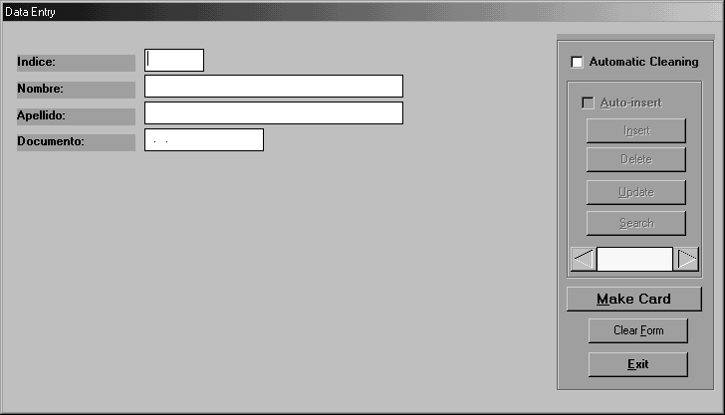
Manual Data Entry

“The number of visible fields changes depending on the selected design”

This option is used when personalization data must be entered manually from your PC keyboard. A form is displayed for the operator to type the data and then issue the card.
Note:
This option is available only if it is enabled in the selected design. The “Enable Manual Entry” box must be checked in the design (see Card Design). This requirement provides the necessary security when you do not want to allow this type of production.

Follow these steps:

- Choose Card Design and click on the Manual Entry button

- A form is displayed to enter the card holder data. Fields number and names match those set in the Design task. All fields are initially empty, except those that have been assigned a Default Value when creating the design.

- Edit the fields. Use Enter or Tab to move across fields. Unlike conventional editors, when you press Enter, you go to the next field without altering the existing data in the selected field, even if the text is highlighted. However, if you type a character, the highlighted data will be replaced with the new text. To make a correction, use the arrow keys to unmark the existing text before editing. The Backspace key deletes the whole field if highlighted. Backspace also takes you to the previous field.

- After competing the form, click on the Print Card button to activate the personalization process (*). Control Panel is displayed on screen. Typically, there are no actions to be taken in Control Panel: simply wait for the card to be personalized. Once the card is completed, the screen goes back to the empty form to edit another card.
* TAB allows you to move across buttons to activate them without using the mouse.

e) If you want to end the Manual Entry task, click on Cancel.

Considerations:

- The Clear button empties all fields and fills in the Default Values. It is useful, for instance, when the operator has accidentally edited some Default Value and does not remember how to restore it.
- When entering data, Ibis validates it according to the type set in Design | Data Format | Data Validation, for each field (Numeric, Alphanumeric or Date). For example, if you try to enter an alphabetic data in a Numeric field, it will be rejected and you will hear a beep tone. The maximum length is also validated, depending on the value set in Design | Data Format | Length for each field.

Data Backup

Ibis saves the manually entered records in a disk file with the following characteristics:
- ASCII Code.
- Format: “Delimited Text”:
- Field Separator: semicolon “;”
- Record Separator: CR+LF
- The file resides in the Audit directory. Every day, a new file is initiated, whose name derives from the current date.
- The first field of each record indicates the Card Design name. The other fields follow the same order set in the Design.
- The record is saved on disk by clicking on the Print Card button. The card is then printed and the empty form is reinitialized to enter a new record.

Database Update

Ibis provides an additional feature in Manual Entry: it allows the Database to be updated with a card data, entered from the keyboard. This feature is available only when the data file uses an Access type database (as set in Design | Data File), where the Enable Insert into Database box should also be checked. Follow the instructions below:

- Choose a Card Design where the Enable Insert into Database option has been activated (only available for Access or Dbase III – IV database type files).
- Choose a Data File (*.mdb). This is the database file where new records will be entered from the keyboard.
- Click on Manual Entry to open the data entry form.
- Edit the fields by entering the card holder data.
- On the top right corner of the form there is a panel with a series of controls (buttons, etc.). If the requirements in a) and b) have been met, these controls will be enabled:

Autoinsert

Check this box if you want Ibis to automatically insert the new record into the database when printing the card.
Note: If the box is unchecked, you may only insert the data manually.

Insert

Click on this button if you want to manually insert the record into the database.

Update

Initially, this button is disabled. Once the current record has been entered (using the Insert key), the button is enabled and you may update the record with the data edited after insertion. This button also works on records retrieved through a search.

Search

It is used to search records in a selected database, using the data as search criteria. Follow these steps:
- Clear the form (by clicking on the Clear button)
- Fill in one or more fields with the data that will serve as search criteria to find the desired record(s).
- Click on Search.
Search result:
- If there is a record that matches the search criteria, its data will be loaded in the form, which will be available for printing and/or updating.
- If more than one record matches the criteria, the form is completed with the first one. The total number of records and their order will be displayed on screen. Use the arrows on the display below the Search button to access the other records. Click on one of these arrows and the form will be updated with the data from the record chosen.
- After choosing the record, you may use it to print a card or to update it.

Note: The search system allows you to access the total number of records simply by making a search with all fields empty.

Clear

It allows you to empty the form fields (or reinitialize them with default data).

Cancel

It allows you to end the Manual Entry process.

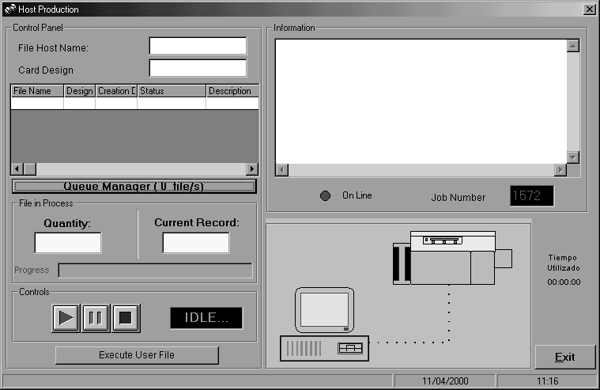
Remote Production

This operation mode allows you to use Ibis to issue cards automatically. It also makes the integration of Host systems easier.

Requirements to use this mode:

Host Requirements:

Connectivity:
The Host should have connectivity allowing the recording of an ASCII file on a hard disk visible by the PC running Ibis (i.e. to be on a LAN network).

For example: In a Novel server.

Data File
The file should meet the specific requirements, even though the data format is almost free since Ibis can adapt to a wide range of formats.

The requirements are as follows:

- File path (directory): It should match the one indicated in Ibis Configuration – Exchange Directory.
- File name: It should match the one indicated in Ibis Configuration – Exchange File.
Note: It accepts wildcard characters.
- File type: ASCII, made up of a Header and then one or more Fixed Length Records.
- Header: Made up of 4 fields, all of them MANDATORY:

- File Name
- Name of the Design to be Used, without extension
- Reference Date (informative during Production)
- Description (informative during production)

Fields must be separated by commas.

Header example:

DATA.TXT,AADVAN,10/5/97,Tarjeta Aadvantage Topper negro

(DATA.TXT,AADVAN,10/5/97,Aadvantage Card black Topper)

- Data Format: It should match the description created in Ibis for the same Design shown in the header.
For further details about the design, see the Configuration→Host Interface Section.

Ibis PC Requirements

- Define all the settings shown in Configuration→Host Interface.
- Be on a LAN network with another PC or file transfer system.

Host Mode Production

Enter Ibis with a Password with Production privileges.
- Click on Production and choose Remote Control.
- Ibis starts in a latent mode and waits for a file that matches one of the names allowed to appear in the displayed directory and immediately starts automatic production.
- The Card Design to be used will be the one displayed in the data file header. The PC should have a Card Design under the same name.
- The Data Format that is part of the Card Design is used to separate each file record into its appropriate fields. Therefore, the data file structure should match the specifications in Data Format.

The Production display is similar to the batch production mode but has fewer indicators since the whole batch is issued and the user cannot restrict the records to be processed.
There are file name and process type fields (Card Design).
The files in queue and the file in progress are also displayed.

Note: The name of the queued file is different from the name of the file sent by the Host. Whenever the Host sends a file to the PC, Ibis copies it in the queue directory and renames it in correlative order. This allows the Host to use always the same file name.

The operator may stop the process by clicking on PAUSE and STOP.

Important:
In this version, if you use STOP and then PLAY, Ibis starts producing the whole file again. If you do not want to process it again, delete the file from the queue from Configuration→Host Interface→Queue Manager

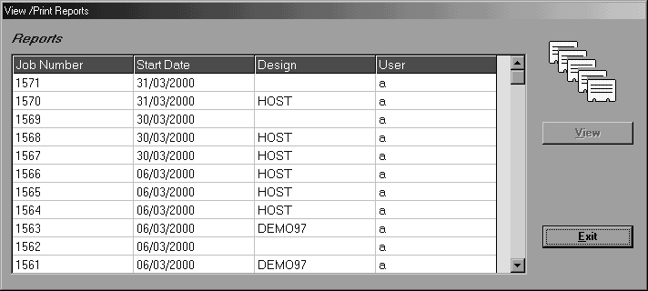

Reports

The Reports task allows you to create a report of the personalization processes carried out. Click on Task→Reports to open the Reports window.

Note: To activate this task, the user should have the Production or Design privilege. Otherwise, the menu item will not be available.

In the Reports window, the operator may choose the repot he/she wishes to View and/or Print through a Job Number (*). Drop down the combo box by clicking on the arrow. The list shows the tasks in a chronological order starting from the most recent. For each task, the list shows the Job Number and the Start Date.

(*) About Job Numbers
Whenever a new production task is started by pressing the Play button, a new Job Number is assigned.
If you use the same batch more than once, a new Job Number will be created.

Report Content

The report consists of two parts: Header and Body.

Report Header
- Job number
- Name of the operator in charge
- Name of the Card Design used
- Data file name
- Task start and end dates
- Production time
- Types of processes involved in personalization (embossing, Topper, etc.)
- Number of properly processed cards

Report Body

- Record Number
- Record Status (indicates whether the report was successfully completed or the type of failure, if any)

Note: The Record Status is relevant only if the Communications Protocol being used is CPX. If the personalization was carried out using Xon/Xoff protocol, there is no environment of the embosser to indicate whether the processing was successful or whether there was any failure.

Report Printing

If you wish to create a printout of the report, press the Print button. (This button is an icon of a printer located at the bottom of the screen) You should have a printer installed on Windows with its driver.

Security / User Management
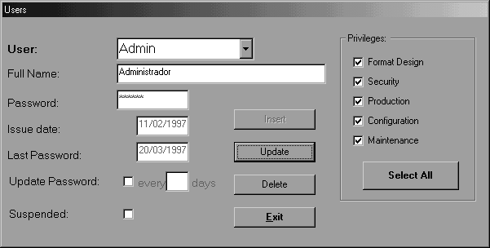
This section describes the different security features of the system, including Users Additions and Deletions as well as the definition of users’ individual privileges over the system.

Click on the Security→Users item to open the Users window.

Note: To activate this task, the user should have the Supervisor privilege. Otherwise, the menu item will not be available.

Users List

To see the list of existing users, click on the arrow next to the User field to open the combo box.
Select a user by clicking on its name. The rest of the fields will automatically fill with the user’s associated data (except the Password, which will have asterisks so as not to disclose the user’s password and prevent its modification).

User’s Data

- The Full Name field is informative and is not used in processes.
- The password and the Addition Date and Password Date fields are grayed because this data cannot be changed by the user.
- When the Renew Password checkbox is checked, it shows the number of days after which the user should change his/her password. By doing so, the password is enabled for a certain number of days and the system updates the Password Date field.
- If the Suspended checkbox is checked, the user will not be able to access the system.
- The Privileges panel defines the user’s permits to access different Ibis features, such as:

- Supervisor: Allows the user to enter the Security→Users task
- Card Design: Allows the user to enter Task→Design and Print Reports
- Production: Allows the user to enter Task→Production and Print Reports
- Configuration: Allows the user to enter the Configuration task

The privileges marked show the tasks the operator may carry out. Privileges do not depend on each other.

Users Management

Additions

To add a new user, follow these steps:
- Type in the individual’s shortened name to be used (or alias) in the User field.
- Press Tab or Enter.
- If the name is new (i.e. if it is not on the list), a dialog box will ask you if you wish to create the new user. Click Yes.
- Enter the Full Name and press Enter.
- Enter the Password (up to 12 digits) and hit Enter.
- The system will prompt you to confirm the password. If the password is not correct, repeat the last two steps until you have entered the password correctly. Do not forget the password and remember that it is case sensitive.
- If you wish, mark the Renew Password checkbox and enter the desired number of days.
- Check at least one Privilege, otherwise, the user will not be allowed to carry out any useful tasks with the program.
- Click on the Insert button.

Deletions

To delete a user just select the desired user from the list and then click on the Delete button. The system will delete the use.

Changes

For any change you want to make, follow this procedure:
- Select a user from the list.
- Change the attributes (Name, Renew Password, Suspended and/or Privileges).
- Click on the Update button to save the changes.

For example, to Suspend a User, select the user, click on the Suspended checkbox making sure a check mark appears in the box and then click on the Update button.

Utilities

Reading Card Counters
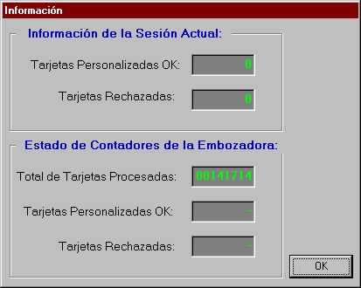

This function allows you to read the embosser’s counters. The displayed information depends on the type of machine:

- DataCard 150i

- Number of cards processed without error
- Number of cards with error
- Total number of cards issued

- DataCard 280

- Total number of cards issued

Follow the instructions below:
- Choose the Utilities→Read Card Counters item.
- The display will show the counters’ current status, provided it can establish communication with the machine.
- Click on the Exit button to go back to the main menu.

Reading the Magnetic Stripe

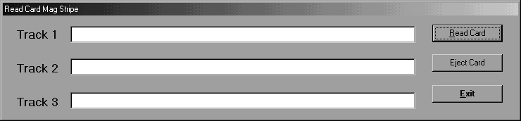
This function allows you to read the three Mag Stripe Tracks of a preencoded card.

- Place the card(s) in the input hopper.
- Choose the Utilities→Read Mag Stripe menu item.
- Click on the Read Card button.
- The display will show the data read from the card.
- Click on the Expel Card button to send the card to the output hopper.
- Click on the Exit button to go back to the main menu.

Note: (Function available only for DataCard 150i)

Running the User File

This function allows you to run the application chosen in the "Configuration" module, in the “Tools” tab.

To test this tool, set the Windows calculator as External File (possible path: C:\WINDOWS\CALC.EXE). Then, go back to the system main window and choose the Utilities→Run User File menu item.

HEX/Decimal/ASCII Table
Clears the Last selected character.
Selected characters.
Cancels the selection and hides the table.
Accepts the selection and hides the table.
Clears all selected characters.
Click to select a character.

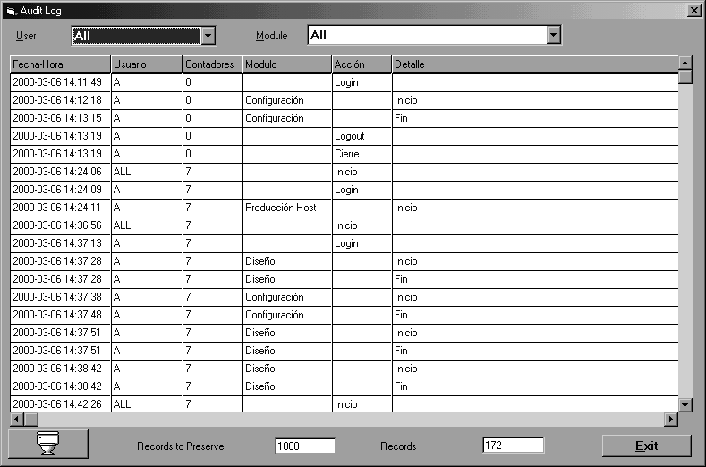
Audit

Ibis creates an audit log file that records the most important actions carried out by the user and can maintain the last 10,000 actions performed.

This information is available when the use of the program has to be audited. The file name is AUDITLOG.TXT and it is located in the same directory as the application software. The file is in ASCII format and the fields are separated by commas.

From the Security menu you can access the Audit window where you can see up to the last 10,000 actions performed. You may view the actions carried out by all users or by a specific individual user. You may also use a filter to display the actions performed per each Ibis module.

You can also Clear or empty the audit log by clicking on the Clear button.

You can limit the number of actions to be saved up to a maximum of 10,000.

Ibis Database Repair ToolKit

The purpose of this application is to Repair and Compress the Microsoft Access type databases internally used by Ibis as well as those generated by the user, Repairing them, in case their access is defected and Compressing them when their size has increased exponentially.

This application is installed during Ibis installation and it may be accessed from the Start menu, within the Ibis for Windows program group.

The application is user-friendly:

First, look for the database you want to repair and compress. Then press the Repair/Compress button.

After completing this task, a red message will indicate that the task has been performed successfully.

Note: this action should be carried out by the system administrator.

APPENDIX “A”

DataCard Connections Diagram

DataCard 150i

Host
Host Service

DataCard 150i Rear View
Connect the PC to the Host connector.

DataCard 280

Standby
Host
Terminal

DataCard 280 Rear View

Connect the PC to the Host connector.

Serial Cable Diagram

Communications Cable:

DataCard null modem cable (“flip cable”), per diagram:

Embosser |  | PC
1 |  | 1 DCD
2 |  | 3 TXD
3 |  | 2 RDX
4 |  | 6 DSR
5 |  | 5 GND
6 |  | 4 DTR
7 |  | 8 CTS
8 |  | 7 RTS

Ibis

Fault Report
In case of failure in the use of the software, please FAX or E-MAIL a report to us. Complete the form, providing as much detail as possible to help us isolate and fix the problem so that together we can achieve an increasingly robust system.

User: Version number:
Site: Equipment:
Optional devices installed:

Description of the problem:

Recorded by: Signature: Date:

E-Mail: ibis_support@ciriloayling.com

Index

A
Administrador de Colas 24
Agregar un Campo 34
Agregar una Línea 42
Archivo Externo 21
ARCHIVO_9000 33
Archivos Access: 31
Archivos Dbase III - IV: 32
Atributos de Cada Tipo de Campo 45
Auditoría 73
C
Campos Variables 43
Card Design 25
Carrier 20, 46
Communications 18
Como elegir el Campo de Búsqueda 48
Concatenado 43
Configuración de SmartCard 29
CONFIGURATION 10
D
Definición del Tipo de Búsqueda 48
Definir Archivos Tipo 9000 ready 38
Descripción Campos de la Página “CAMPO DE BUSQUEDA” 47
Descripción Campos de la Página “FORMATO DE DATOS” 30
Descripción Campos de la Página “FORMATO DE TARJETA” 41, 47
Descripción Campos de la Página “GENERALES” 27
E
Equipment 11
Espacios 44
F
Financial Password: 12
First Time Procedure 13
FORMATO DE DATOS - Archivos Tipo 9000 Ready 37
Functionality 4
H
Host Interface 22
I
Incluir Campo 43
Initial Configuration 8
INSTALATION 5
Introduction 4
L
Largo de Registro 34
M
Main Windows 7
Manejo de Diseños: 26
Manejo de Diseños: 26
O
Otros Tipos de Archivo 32
P
Panel de Control (costado izquierdo) 51
Para crear un nuevo Diseño: 25
Para elegir un Diseño existente: 25
POINT & SHOOT: 36
Preferences 16
Procedimiento a Utilizar la Primera Vez 13
Producción Local 50
Producción por Lotes 53
Propiedades de Cada Campo 34
Propiedades del Campo de Búsqueda 48
R
Registros de un Archivo Tipo 9000 Ready 38
S
Separador de Campo 34
Separador de Registro 34
Sustitución de caracteres 20
T
Texto Fijo 43
TEXTO_DELIMITADO 32
TEXTO_LARGO_FIJO 32
Tools 20

“Page intentionally left blank”

